Background:

Eurosystem provides a comprehensive questionnaire containing numerous requirements that must be fulfilled. These requirements apply to the entire organization, not just TARGET-related areas. For example, topics such as HR and physical security are included.

In previous years, our focus was on requirements with direct relevance to TARGET. For those, we reviewed open findings and, based on their risk rating, determined whether a requirement was non-compliant.

This year, the approach has changed: we aim to attest compliance with Eurosystem requirements.

I identified requirements directly relevant to TARGET, such as:
- Asset Management
- Operations Management (partially relevant)
- Access Control (partially relevant)

The basis for relevance was any mention of the payment transaction chain and TARGET. For these areas, I created DE and OE tests and started fieldwork. Within this scope, I can conclude whether a requirement is compliant (no observation) or non-compliant (observation).

Vish and I discussed whether it would be possible to also comment on compliance for other requirements. We considered mapping other audits to these requirements. However, even in that case, we could only identify non-compliance. To confirm compliance, the audit scope would need to fully match a Eurosystem requirement—which is never the case.

Looking ahead to next year, I propose that we include all Eurosystem requirements as part of the scope for all audits (IT and business, where appropriate). This would allow us to confidently state that ECAG is compliant.

Let’s discuss.

Concept TARGET attestation

Business information
Audit in 2025: 2025-029 Payment Services (ECAG)
ICS processes with potential relevance for payment: ICS controls Q3 2025.xlsx (16 processes)
Process owners:
- Giovanna Krejcirova van Swaay
- Markus Holecz
- Nadezhda Ermakova
- Peter Hochstein
- Roman Zeiß
- Stefan Gasper

Overview on TARGET IT infrastructure
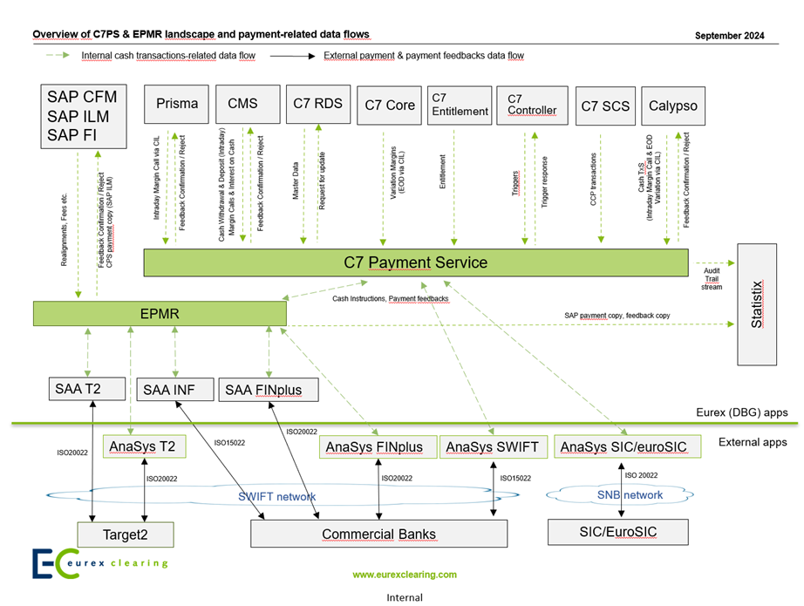
According to APMS (applications with components.xlsx) the following applications and associated components are relevant for TARGET:
- C7 (AID021) with components:
  - C7-Payment-GUI-Middleware
  - C7-Payment-GUI
  - C7-Payment-Core
  - C7-EPMR
- CASCADE (AID022) with components:
  - Settlement Engine for non-T2S-Settlement
  - Position Update Engine for T2S-Settlemen
- Swift Connectivity (AID512) with component:
  - SWIFT ALLIANCE ACCESS – SAA
- C7 SCS (AID596) with component:
  - SCS-SWIFT-Gateway
Responsible persons:
- C7: app owner Ashish Malode, business owner: Markus Holecz
- CASCADE: app owner Bernhard Brütting, business owner: Volker Kresin
- Swift Connectivity: app owner: Ludovic Lecanuet, business owner: Priya Sharma
- C7 SCS: app owner: Srinivas Garidepally, business owner: Markus Holecz

Requirement 1.1: Information security policy
Management shall set a clear policy direction in line with business objectives and demonstrate support for, and commitment to, information security through the issuance, approval and maintenance of an information security policy aiming at managing information security and cyber resilience across the organisation in terms of identification, assessment and treatment of information security and cyber resilience risks. The policy should contain at least the following sections: objectives, scope (including domains such as organization, human resources, asset management etc.), principles and allocation of responsibilities.
General topic, no specific relevance to TARGET.
- Cyber Security audit

Requirement 1.2: Internal organisation
An information security framework shall be established to implement the information security policy within the organisation. Management shall coordinate and review the establishment of the information security framework to ensure the implementation of the policy across the organisation, including the allocation of sufficient resources and assignment of security responsibilities for this purpose.
General topic, no specific relevance to TARGET.
- Cyber Security audit

Requirement 1.3: External parties
The security of the organisation’s information and information processing facilities should not be reduced by the introduction of and/or dependence on an external party/parties or products/services provided by them. Any access to the organisation’s information processing facilities by external parties shall be controlled. When access by external parties or products/services from external parties is/are required, a risk assessment shall be carried out to determine the security implications and control requirements. Controls shall be agreed and defined in an agreement with each relevant external party.
General topic, no specific relevance to TARGET.
- Ask app owner if external parties are used
Potential business audits?

Requirement 1.4: Asset management (relevant)
All information assets, the business processes and the underlying information systems, such as operating systems, infrastructures, business applications, off-the-shelf products, services and user-developed applications, in the scope of the Payment Transaction Chain shall be accounted for and have a nominated owner. The responsibility for the maintenance and the operation of appropriate controls in the business processes and the related IT components to safeguard the information assets shall be assigned.
NOTE: The implementation of specific controls can be delegated by the owner as appropriate, but the owner remains accountable for the proper protection of the assets.

DE test
- Identify Payment Transaction Chain (PTC) relevant information assets, business processes and underlying information systems, such as operating systems, infrastructures, business applications, off-the-shelf products, services and user-developed applications.
- Assess if an owner is nominated for these assets.
- Assess if the responsibility for the maintenance and the operation of appropriate controls in the business processes and the related IT components to safeguard the information assets is assigned.

OE test
n/a

Requirement 1.5: Information assets classification
Information assets shall be classified in terms of criticality to the smooth delivery of the service by the participant. The classification shall indicate the need, priorities and degree of protection required when handling it in the relevant business processes and by the underlying IT components. An information asset classification scheme approved by the management shall be used to define an appropriate set of protection controls across the information asset lifecycle, including removal and destruction, and communicate the need for special handling measures.
General topic, no specific relevance to TARGET.
- Risk assessment

Requirement 1.6: Human resources security
Security responsibilities shall be addressed prior to employment in adequate job descriptions and in terms and conditions of employment. All candidates for employment, contractors and third-party users shall be adequately screened, especially for sensitive jobs. Employees, contractors and third-party users of information processing facilities shall sign an agreement on their security roles and responsibilities. An adequate level of awareness shall be ensured among all employees, contractors and third-party users, and education and training in security procedures and the correct use of information processing facilities shall be provided to them, to minimise possible security risks. A formal disciplinary process (for employees) for handling security breaches shall be established. Responsibilities shall be in place to ensure an employee’s, contractor’s or third-party user’s exit from or transfer within the organisation is managed, and that the return of all equipment and the removal of all access rights are completed.

General topic, no specific relevance to TARGET.
- Check HR audit

Requirement 1.7: Physical and environmental security
Critical or sensitive information processing facilities shall be housed in secure areas, protected by defined security perimeters, with appropriate security barriers and entry controls. They shall be physically protected from unauthorised access, damage and interference. Access should be granted only to individuals who are in scope of Requirement 1.6. Procedures and standards shall be established to protect physical media containing information assets when in transit.
Equipment shall be protected from physical and environmental threats. Protection of equipment (including that used off-site) and against the removal of property is necessary to reduce the risk of unauthorised access to information and to guard against loss or damage. Special measures may be required to protect against physical threats and to safeguard supporting facilities such as the electrical supply and cabling infrastructure.

General topic, no specific relevance to TARGET.
- Check data center audit

Requirement 1.8: Operations management (relevant)
Responsibilities and procedures shall be established for the management and operation of information processing facilities covering end-to-end all the underlying systems in the Payment Transaction Chain.
As regards operating procedures, including technical administration of IT systems, segregation of duties shall be implemented, where appropriate, to reduce the risk of negligent or deliberate system misuse. Where segregation of duties cannot be implemented due to documented objective reasons, compensatory controls shall be implemented following a formal risk analysis.
Controls shall be established to prevent and detect the introduction of malicious code for systems in the Payment Transaction Chain. Controls shall be also established (including user awareness) to prevent, detect and remove malicious code.
Mobile code shall be used only from trusted sources (e.g. signed Microsoft COM components and Java Applets). The configuration of the browser (e.g. the use of extensions and plugins) shall be strictly controlled.
Data backup and recovery policies shall be implemented and it shall include a plan of the restoration process which is tested at regular intervals at least annually.
Systems that are critical for the security of payments shall be monitored and relevant information security events shall be recorded. Operator logs shall be used to ensure that information system problems are identified. Operator logs shall be regularly reviewed based on the criticality of the operations, on a sample basis. System monitoring shall be used to check the effectiveness of controls which are identified as critical for the security of payments and to verify conformity to an access policy model.
Exchanges of information between organisations shall be based on a formal exchange policy and carried out in line with exchange agreements among the involved parties and shall be compliant with any relevant legislation. Third-parties software components employed in the exchange of information with TARGET (e.g. software received from a Service Bureau in scenario 2 of the scope section) must be used under a formal agreement with the third-party.
Partly applicable to TARGET.

DE test
- Assess the controls to prevent and detect the introduction of malicious code for systems in the Payment Transaction Chain.
- Assess the controls which prevent and detect the introduction of malicious code for systems in the Payment Transaction Chain.
- Assess controls (including user awareness) which prevent, detect and remove malicious code.
- Assess if systems that are critical for the security of payments, are connected to SIEM and use cases which fulfil the Bundesbank Eurosystem requirements, are implemented.

Requirement 1.9: Access control (relevant)
Access to information assets shall be justified on the basis of business requirements (need-to-know) and according to the established framework of corporate policies (including the information security policy). Clear access control rules shall be defined based on the least-privilege principle to reflect closely the needs of the corresponding business and IT processes. Where relevant (e.g. for backup management), logical access control should be consistent with physical access control unless there are adequate compensatory controls in place (i.e. encryption, personal data anonymization).
Formal and documented procedures shall be in place to control the allocation of access rights to information systems and services in the scope of the Payment Transaction Chain. The procedures shall cover all stages in the life cycle of user access, from the initial registration of new users to the final deregistration of users that no longer require access. Special attention shall be given, where appropriate, to the allocation of access rights of such criticality that the use of them could lead to a severe adverse impact on the operations of the participant (e.g. system administration, override of system controls, direct access to business data).
Appropriate controls shall be put in place to identify, authenticate and authorize users at specific points in the organisation’s network, e.g. for local and remote access to systems in the Payment Transaction Chain. Personal accounts shall not be shared in order to ensure accountability.
For passwords, rules shall be established and enforced by specific controls to ensure that passwords cannot be easily guessed, e.g. complexity rules and limited-time validity. A safe password recovery and/or reset protocol shall be established.
A policy shall be developed and implemented on the use of cryptographic controls to protect the confidentiality, authenticity and integrity of information. A key management policy shall be established to support the use of cryptographic controls.
There shall be policy for viewing confidential information on screen or in print (e.g. a clear screen, a clear desk policy)” to reduce the risk of unauthorised access.
When working remotely, the risks of working in an unprotected environment shall be considered and appropriate technical and organizational controls are applied.

Partly applicable to TARGET.

DE test
- Assess the procedures for access rights management if they fulfil the TARGET requirements.
- …

Requirement 1.10: Information systems acquisition, development and maintenance
Security requirements shall be identified and agreed prior to the development and/or implementation of information systems.
Appropriate controls shall be built into applications, including user-developed applications, to ensure correct processing. These controls shall include the validation of input data, internal processing and output data. Additional controls may be required for systems that process, or have an impact on, sensitive, valuable or critical information. Such controls shall be determined on the basis of security requirements and risk assessment according to the established policies (e.g. information security policy, cryptographic control policy).
The operational requirements of new systems shall be established, documented and tested prior to their acceptance and use. As regards network security, appropriate controls, including segmentation and secure management, should be implemented based on the criticality of data flows and the level of risk of the network zones in the organisation. There shall be specific controls to protect sensitive information passing over public networks.
Access to system files and program source code shall be controlled and IT projects and support activities conducted in a secure manner. Care shall be taken to avoid exposure of sensitive data in test environments.
Project and support environments shall be strictly controlled. Deployment of changes in production shall be strictly controlled. A risk assessment of the major changes to be deployed in production shall be conducted.
Regular security testing activities of systems in production shall also be conducted according to a predefined plan based on the outcome of a risk-assessment, and security testing shall include, at least, vulnerability assessments. All the shortcomings highlighted during the security testing activities shall be assessed and action plans to close any identified gap shall be prepared and followed up in timely fashion.
Put in scope

Requirement 1.11: Information security in supplier relationships
To ensure protection of the participant’s internal information systems that are accessible by suppliers, information security requirements for mitigating the risks associated with supplier’s access shall be documented and formally agreed upon with the supplier.
General topic, no specific relevance to TARGET.

Requirement 1.12: Management of information security incidents and improvements
To ensure a consistent and effective approach to the management of information security incidents, including communication on security events and weaknesses, roles, responsibilities and procedures, at business and technical level, shall be established and tested to ensure a quick, effective and orderly and safely recover from information security incidents including scenarios related to a cyber-related cause (e.g. a fraud pursued by an external attacker or by an insider). Personnel involved in these procedures shall be adequately trained.
General topic, no specific relevance to TARGET.

Requirement 1.13: Technical compliance review
A participant’s internal information systems (e.g. back-office systems, internal networks and external network connectivity) shall be regularly assessed for compliance with the organization’s established framework of policies (e.g. information security policy, cryptographic control policy).
General topic, no specific relevance to TARGET.

Requirement 1.14: Virtualization
Guest virtual machines shall comply with all the security controls that are set for physical hardware and systems (e.g. hardening, logging). Controls relating to hypervisors must include:
- hardening of the hypervisor and the hosting operating system
- regular patching
- strict separation of different environments (e.g. production and development).

Centralized management, logging and monitoring as well as managing of access rights, in particular for high privileged accounts, shall be implemented based on a risk assessment. Guest virtual machines managed by the same hypervisor shall have a similar risk profile.
General topic, no specific relevance to TARGET.

Requirement 1.15: Cloud computing
The usage of public and/or hybrid cloud solutions in the Payment Transaction Chain must be based on a formal risk assessment taking into account the technical controls and the contractual clauses related to the cloud solution. If hybrid cloud solutions are used, it is understood that the criticality level of the overall system is the highest one of the connected systems. All on-premises components of the hybrid solutions must be segregated from the other on-premises systems.
If we only consider the systems mentioned in chapter “Overview on TARGET infrastructure”, this requirement has no relevance for TARGET as they are hosted on-prem.

Business continuity management (applicable only to critical participants)
The following requirements (2.1 to 2.6) relate to business continuity management. Each RTGS DCA holder or Ancillary System classified by the Eurosystem as being critical for the smooth functioning of the RTGS service must have a business continuity strategy in place comprising the following elements.
General topic, no specific relevance to TARGET.

Requirement 2.1
Business continuity plans have been developed and procedures for maintaining them are in place.

Requirement 2.2
An alternate operational site must be available.

Requirement 2.3
The risk profile of the alternate site must be different from that of the primary site, in order to avoid that both sites are affected by the same event at the same time. For example, the alternate site should be on a different power grid and central telecommunication circuit from those of the primary business location.

Requirement 2.4
In the event of a major operational disruption rendering the primary site inaccessible and/or critical staff unavailable, the critical participant must be able to resume normal operations from the alternate site, where it must be possible to properly close the business day and open the following business day(s).

Requirement 2.5
Procedures must be in place to ensure that the processing of transactions is resumed from the alternate site within a reasonable timeframe after the initial disruption of service and commensurate to the criticality of the business that was disrupted.

Requirement 2.6
The ability to cope with operational disruptions must be tested at least once a year and critical staff must be aptly trained. The maximum period between tests shall not exceed one year.

